Lesson 05 Demo 05

Creating a Network Virtual Appliance

Objective: To create a network virtual appliance to implement the user-defined route instead of system routes
Tools Required: Azure account with administrator access

Prerequisites: None

Steps to be followed:
- Create a network virtual appliance
- Enable IP forwarding for the network interface
- Enable IP forwarding for the appliance
- Create a virtual machine

Step 1: Create a network virtual appliance

- Log in to the Cloud Shell. Run the following commands to create the nva:

az group create --name myownresource --location eastus

az vm create \
--resource-group myownresource \
--name nva \
--image Ubuntu2404 \
--admin-username simpli \
--admin-password simplilearn@123 \
--vnet-name nva-vnet \
--subnet nva-subnet \
--storage-sku Standard_LRS

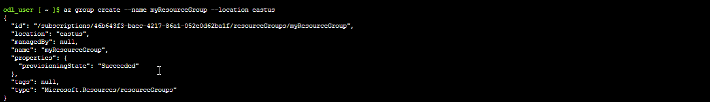

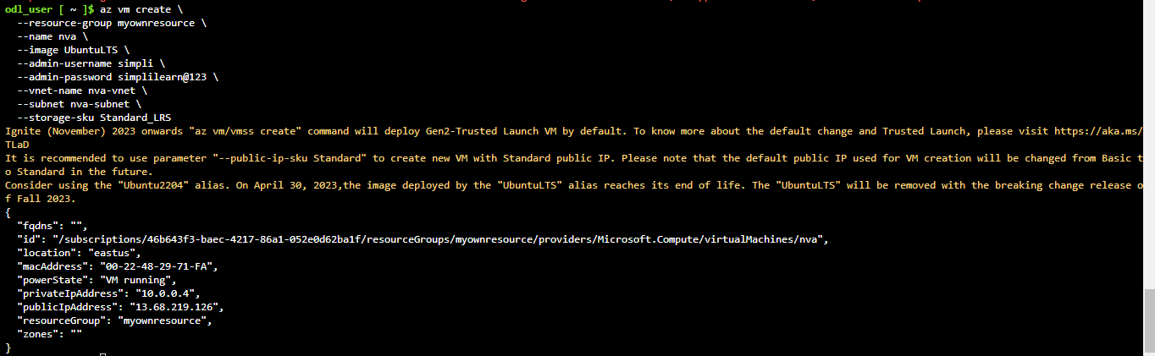

Step 2: Enable IP forwarding for the network interface

- Run the following command to get the network interface ID:

NICID=$(az vm nic list \
--resource-group MYOWNRESOURCE \
--vm-name nva \
--query "[].{id:id}" --output tsv)

echo $NICID

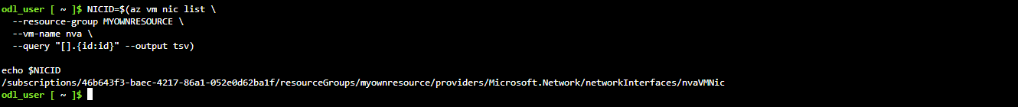

  - Run the following command to get the network interface name:

NICNAME=$(az vm nic show \
--resource-group MYOWNRESOURCE \
--vm-name nva \
--nic $NICID \
--query "{name:name}" --output tsv)

echo $NICNAME

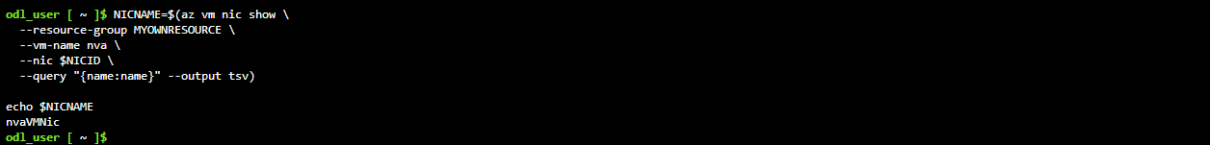

  - Run the following command to enable IP forwarding for the network interface:

az network nic update --name $NICNAME \
--resource-group MYOWNRESOURCE \
--ip-forwarding true

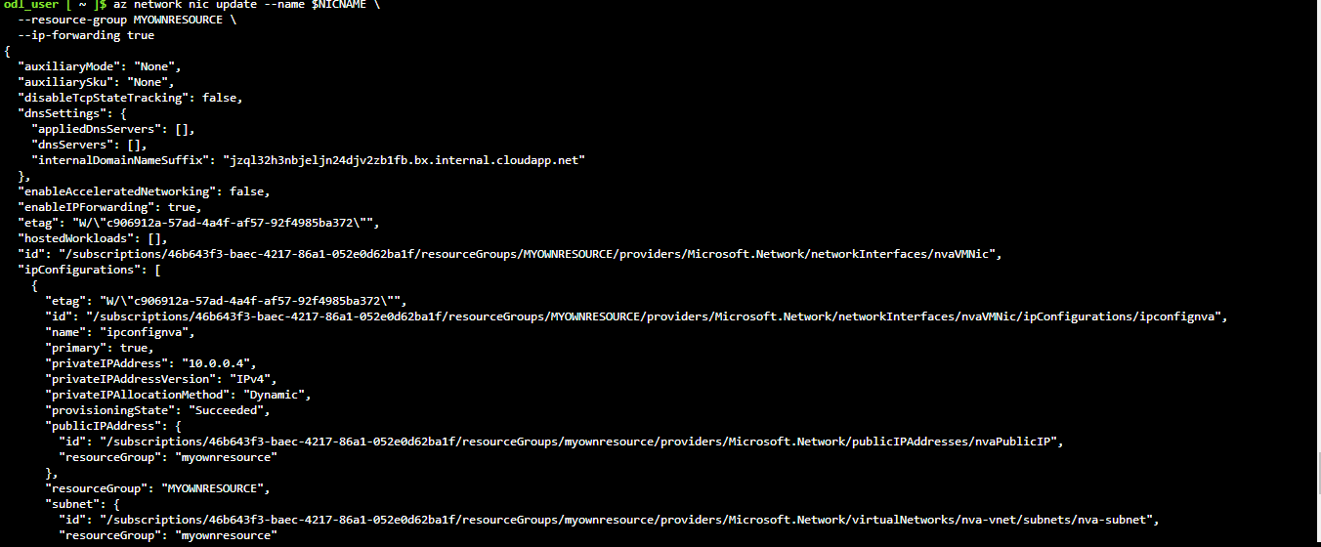

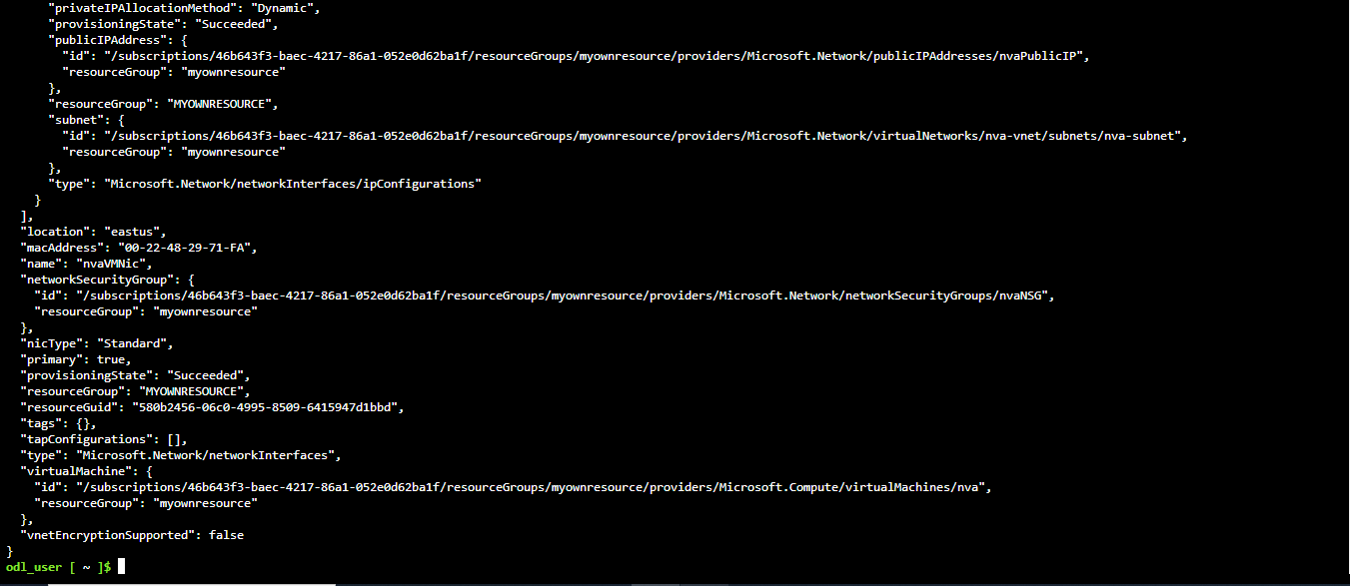

Step 3: Enable IP forwarding for the appliance

- Run the following command to get the public IP of the nva virtual machine:

NVAIP="$(az vm list-ip-addresses \
--resource-group MYOWNRESOURCE \
--name nva \
--query "[].virtualMachine.network.publicIpAddresses[*].ipAddress" \
--output tsv)"

echo $NVAIP

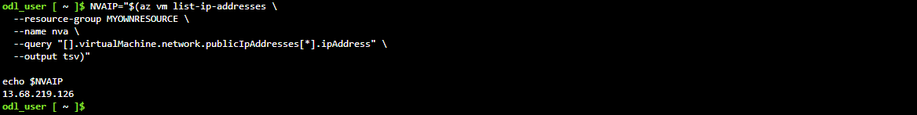

  - Run the following command to enable the IP forwarding for the nva virtual machine:

ssh -t -o StrictHostKeyChecking=no simpli@$NVAIP ‘sudo sysctl -w net.ipv4.ip_forward=1 && exit’

Step 4: Create a virtual machine

- In the Cloud Shell, create a cloud-init.txt file with the following command:

nano cloud-init.txt

#cloud-config
package_upgrade: true
packages:
- inetutils-traceroute

Note: One prompt will automatically appear after entering the command
nano cloud-init.txt; enter the following command at that prompt:
#cloud-config
package_upgrade: true
packages:
- inetutils-traceroute

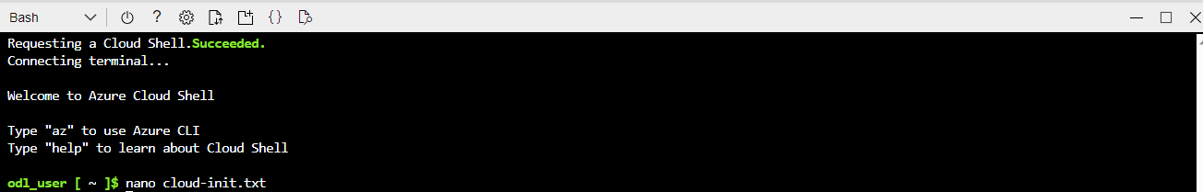

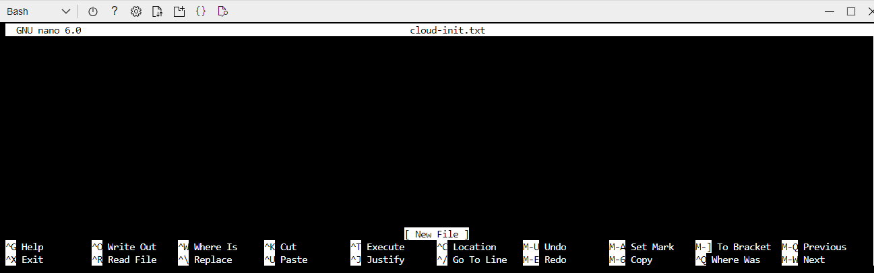

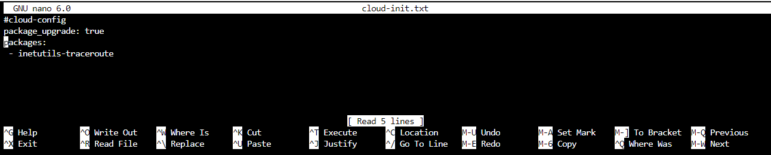

  - Create vm2 by executing the following command:

az vm create --resource-group myownresource --name vm2 --vnet-name nvaVnet --subnet nvaSubnet --image Ubuntu2404 --admin-username testuser --custom-data cloud-init.txt --admin-password Testuser123456 --storage-sku Standard_LRS

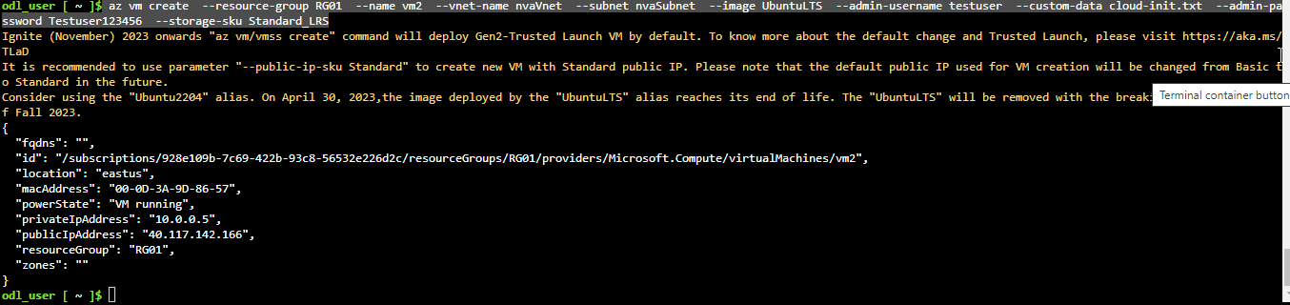

  - Create vm4 by executing the following command:

az vm create --resource-group myownresource --name vm4 --vnet-name nvaVnet --subnet nvaSubnet --image Ubuntu2404 --admin-username testuser --custom-data cloud-init.txt --admin-password Testuser123456 --storage-sku Standard_LRS

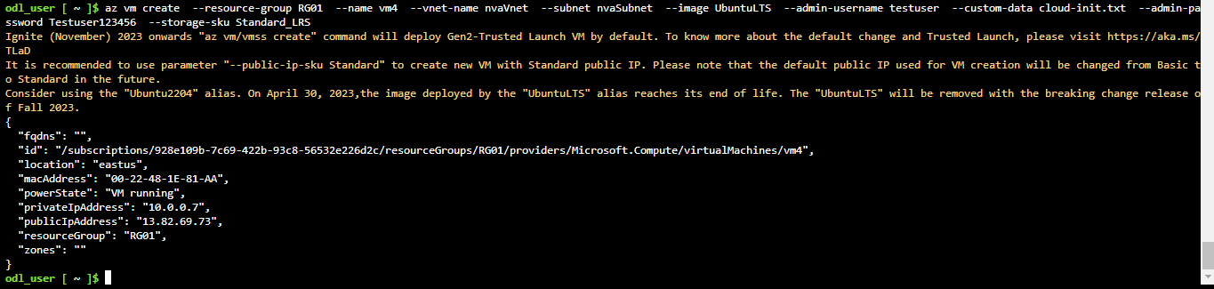

  - Get the public IP of vm2 by executing the following command:

VM1IP=$(az vm list-ip-addresses \
--resource-group myownresource \
--name vm2 \
--query "[].virtualMachine.network.publicIpAddresses[*].ipAddress" \
--output tsv)

echo $VM1IP

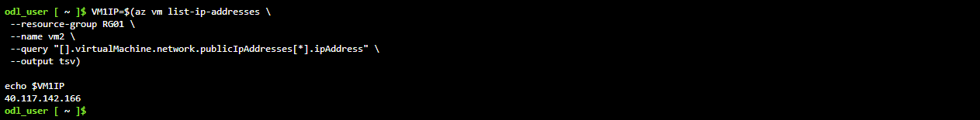

  - Get the public IP of vm4 by executing the following command:
VM1IP=$(az vm list-ip-addresses \
--resource-group myownresource \
--name vm4 \
--query "[].virtualMachine.network.publicIpAddresses[*].ipAddress" \
--output tsv)

echo $VM1IP

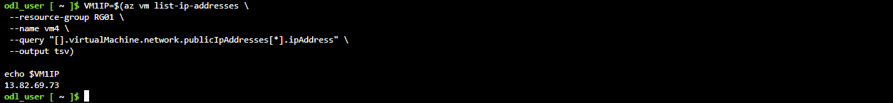

  - Run the following command to trace the route from vm2 to vm4:

ssh -t -o StrictHostKeyChecking=no testuser@$VM1IP 'traceroute vm2 --type=icmp; exit'

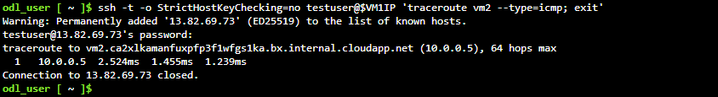

You have now successfully created the network virtual appliance to implement the user-defined route instead of system routes.

